Table of Contents

Lecture 1/5/2018 – n1 2

Settings 2

Set auto import for added classes: 3

onCreate 3

Virtual Devices Manager 4

Layout update 4

Change width: 5

Working with ID 5

Get references to Widgets 6

Create new Activity 7

Lecture 1/8/2018 – Lecture 2 8

Creating Event Listeners 8

Log 8

Check button event listener 9

LogCat 9

Override for any method 9

Debug 10

Gradle 11

Assignment 2 11

Lecture 3 11

Assignment 3: 11

Start activity For Result 12

Lecture 4 – 1/18/2018 13

Nested Classes 13

Shared preferences 14

Emulator Accelerator 15

Assignment 5 – Calculator 16

Lecture 6 – 1/19/2018 17

Get google maps api key 17

Add permission 17

Lecture 7 – 1/29/2018 17

Multithreading 17

Lecture 8 – 2/1/2018 18

Initialization block 18

# Lecture 1/5/2018 – n1

## Settings

File 🡪 Settings

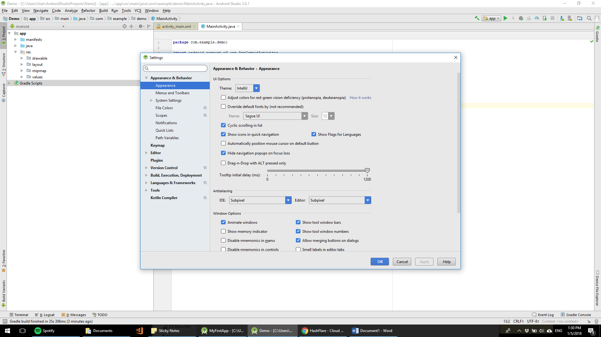

## Set auto import for added classes:

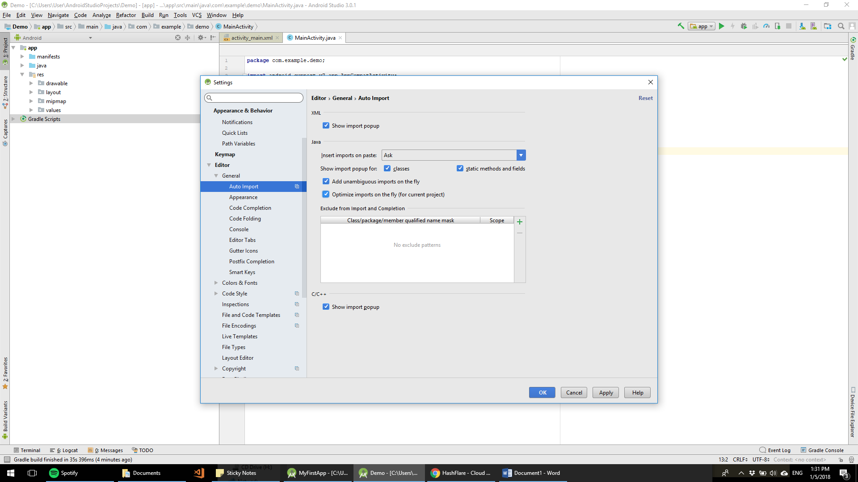

## onCreate

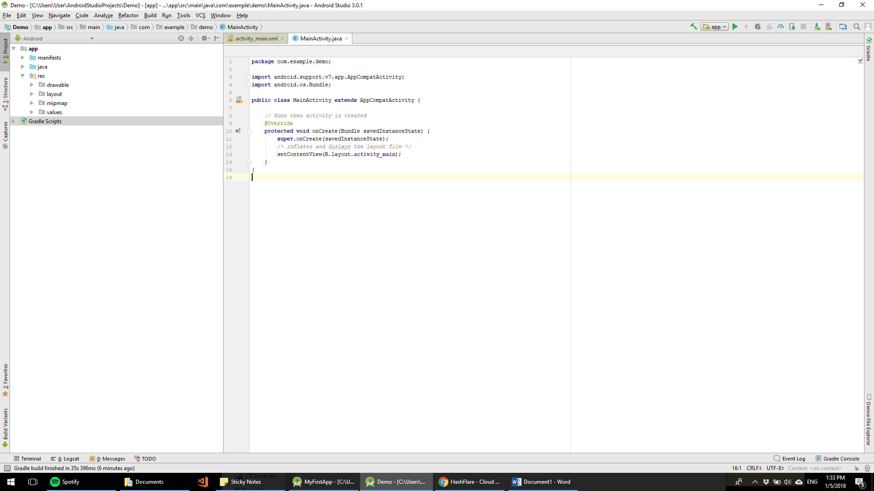

R = res directory

R.layout– references resources from java/res/layout directory

## Virtual Devices Manager

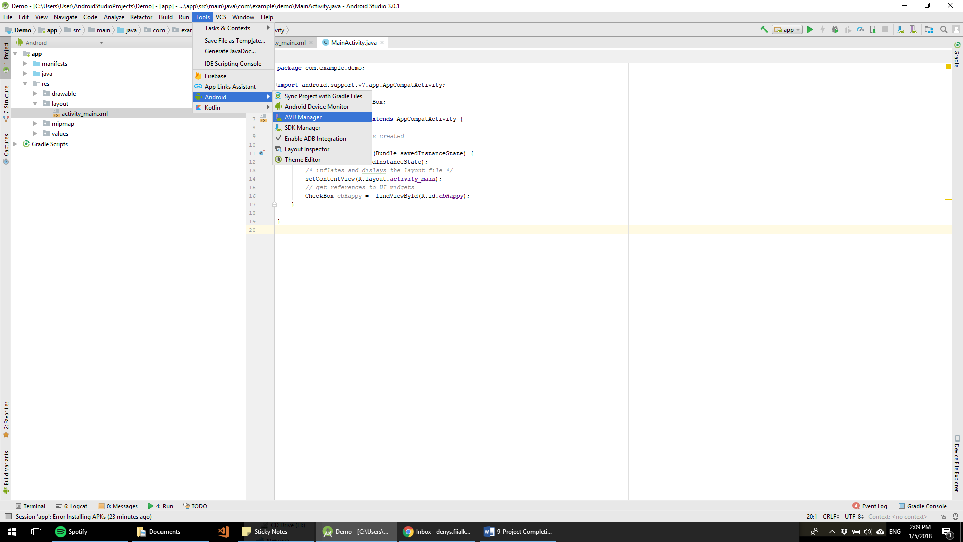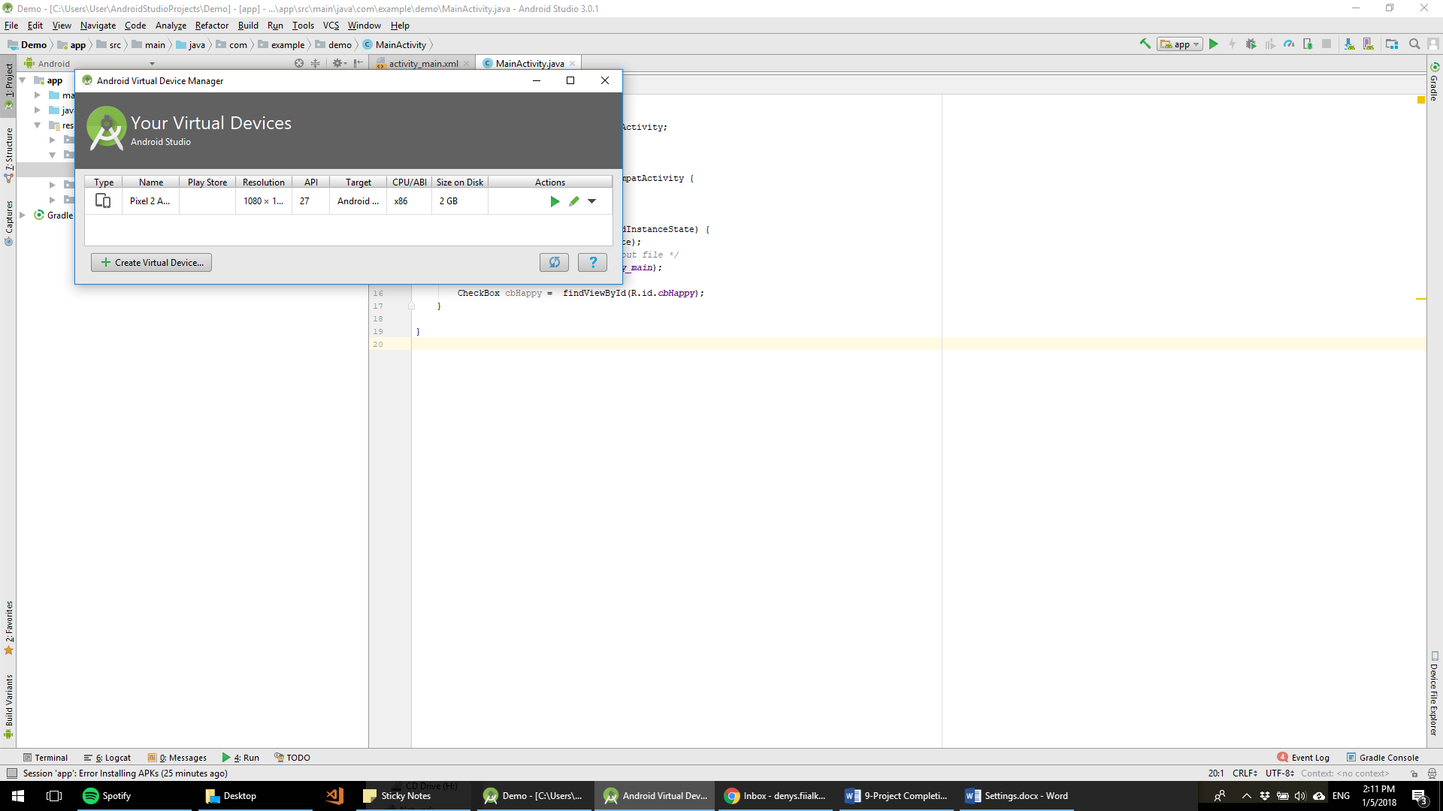

## Layout update

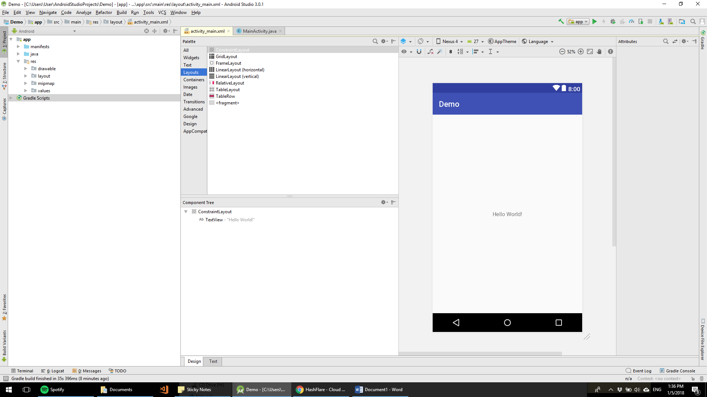

## Change width:

Press Ctrl+Space in layout_width/settings/…

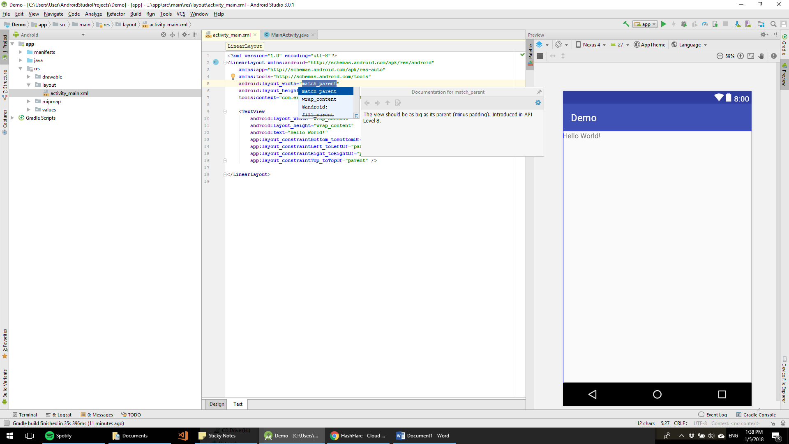

## Working with ID

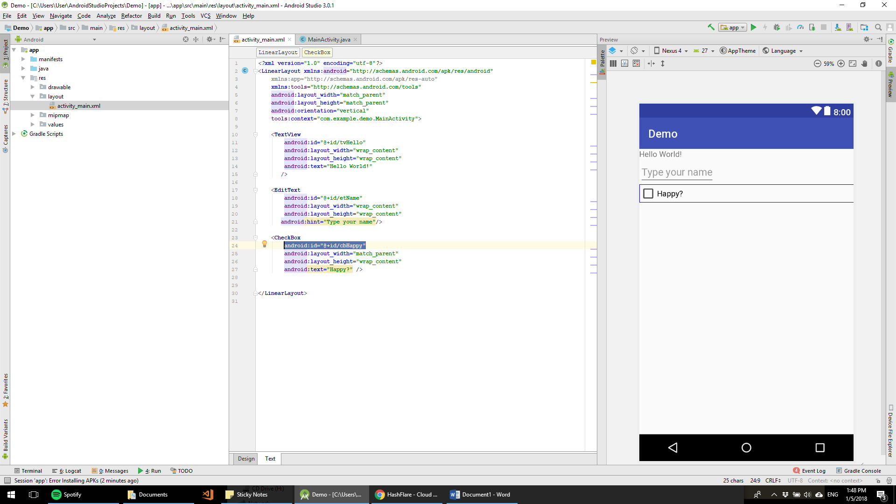

CheckBox cbHappy =findViewById(R.id.***cbHappy***);

## Get references to Widgets

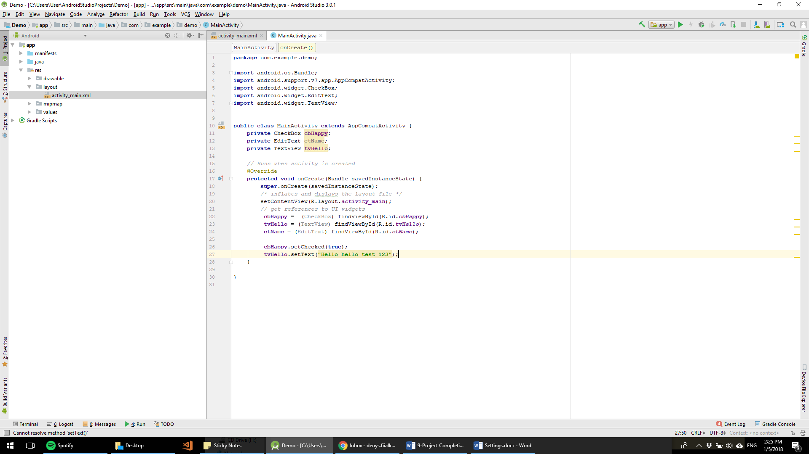

**Define controls**

**Get references by ID**

## Create new Activity

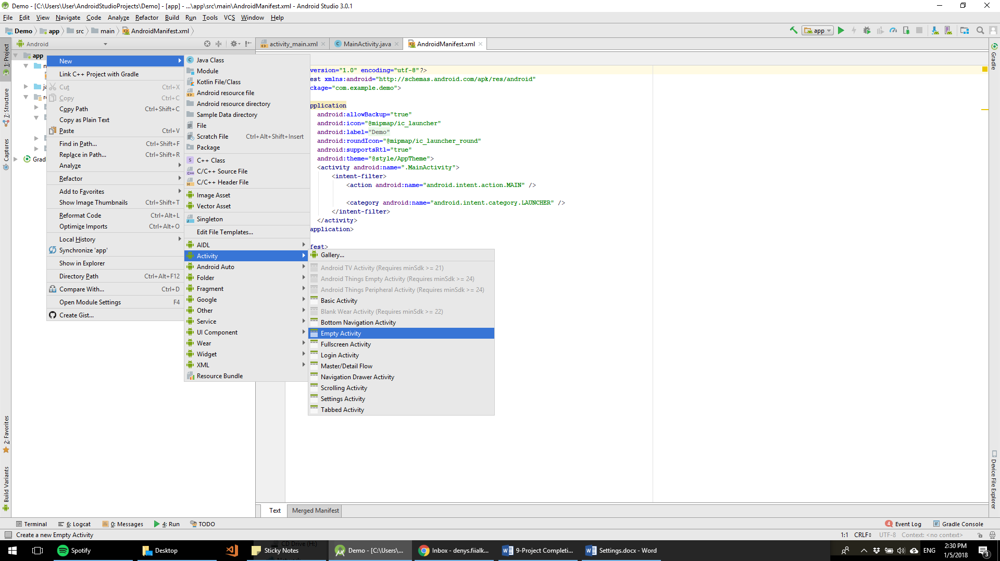

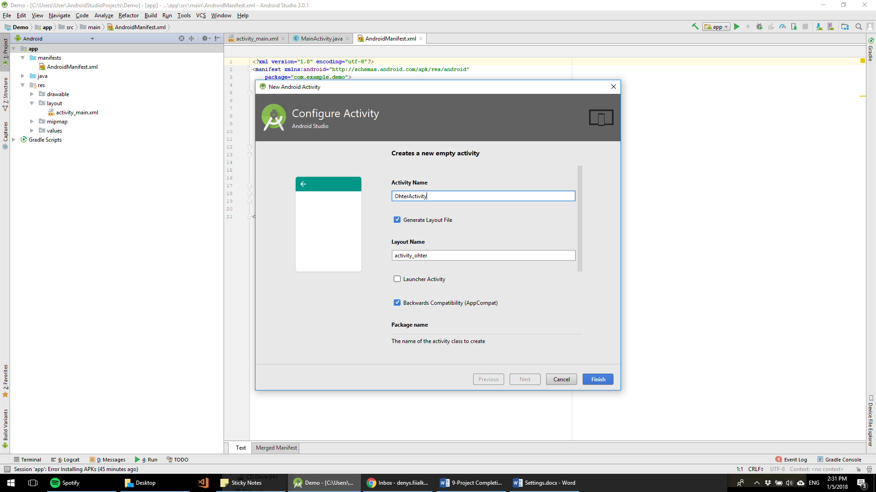

# Lecture 1/8/2018 – Lecture 2

## Creating Event Listeners

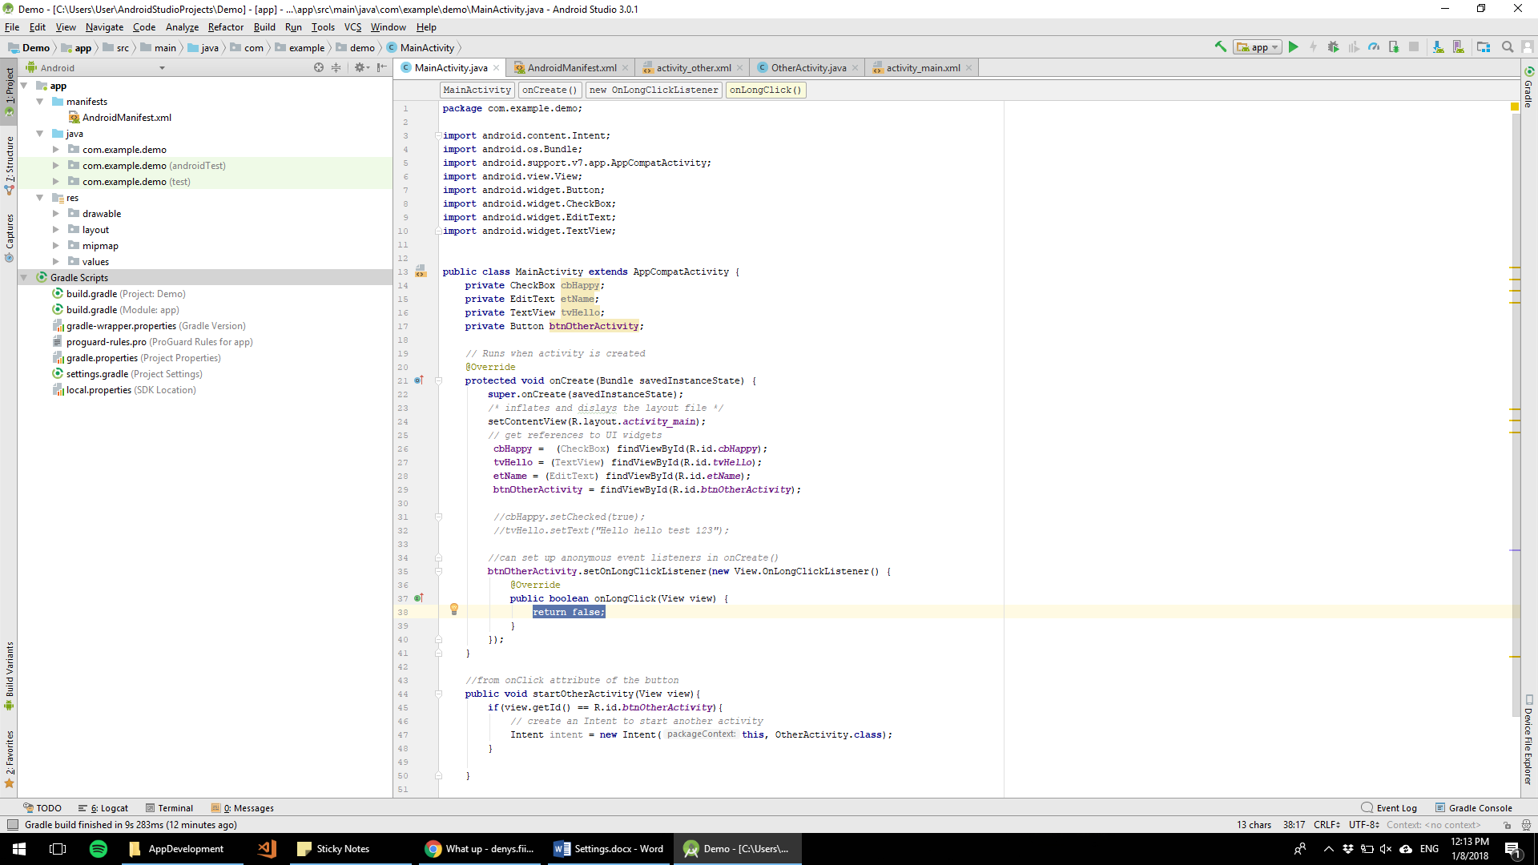

Code whatever you want to happen inside onLongClick

## Log

Log.d – debug

Log.i – info

Log.w – want

Log.e – error

Log.wtf – bad error

## Check button event listener

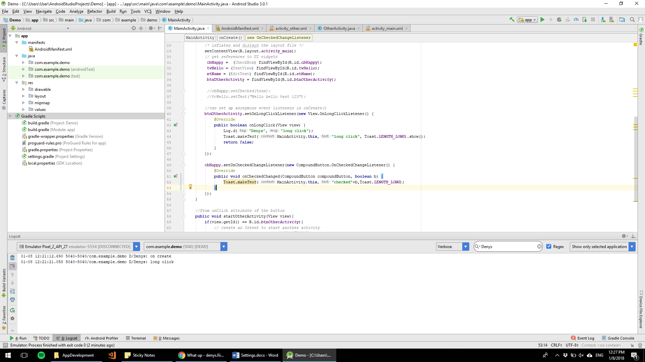

## LogCat

Keeps log of all events in the app

Can be filtered : by tag/warning

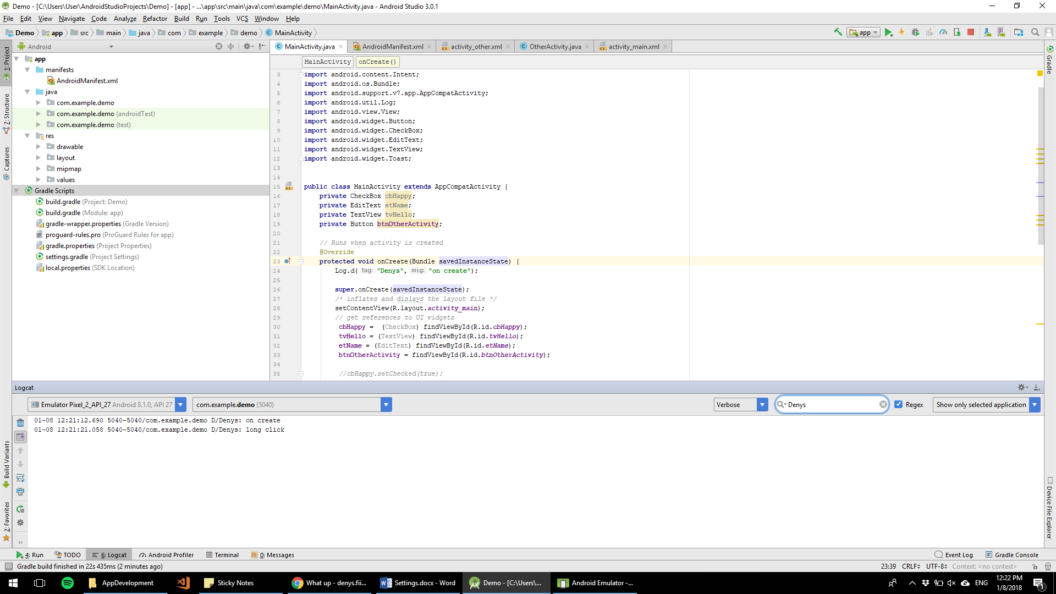

## Override for any method

Ctrl + O

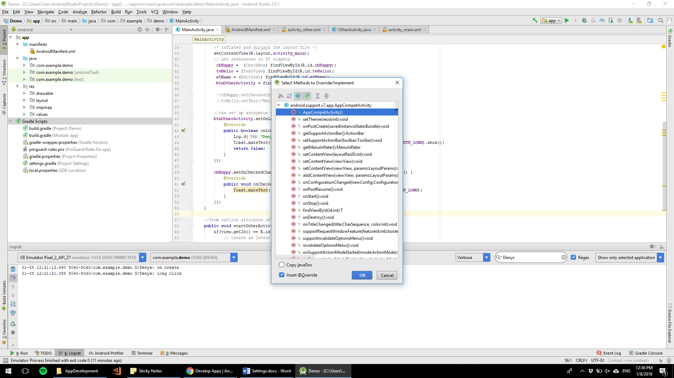

## Debug

Set Breakpoint and run in debug mode

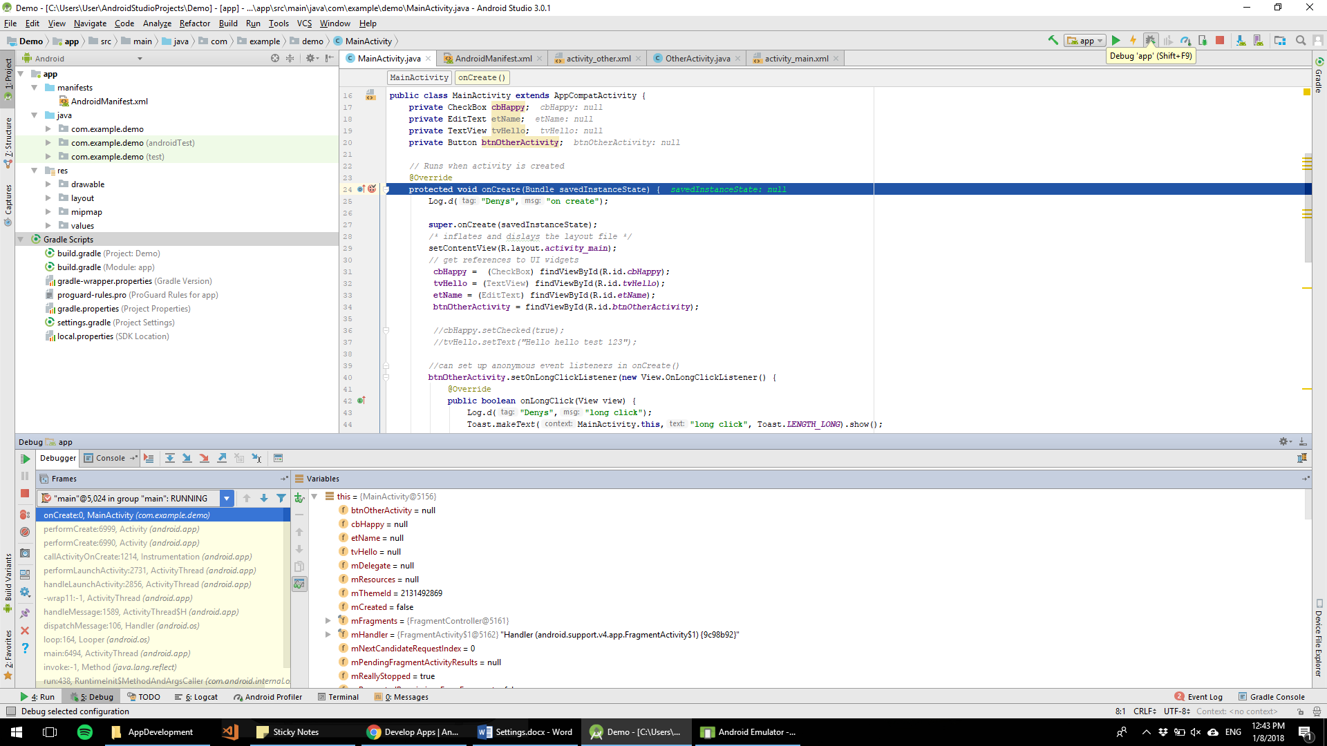

## Gradle

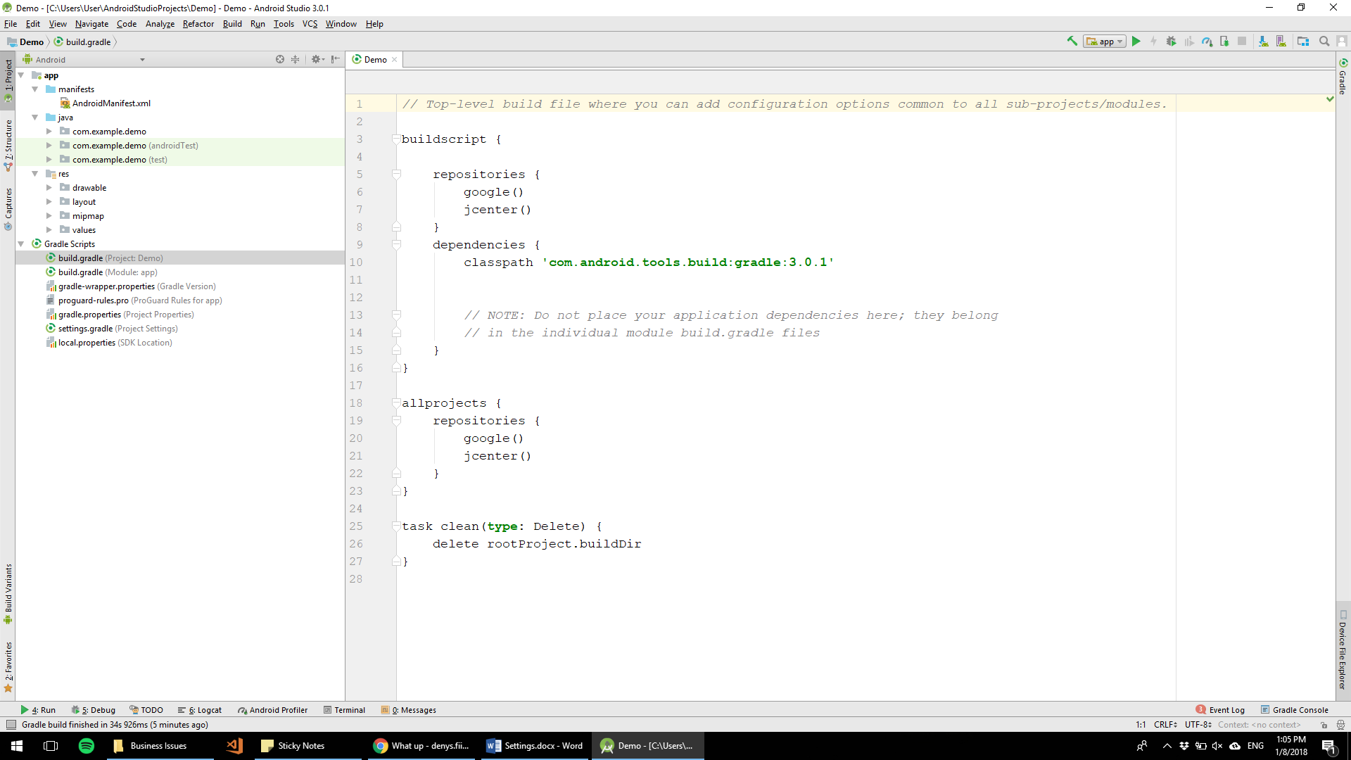

Assignment 2: Activity Lifecycles (reading and coding). Type questions and comments into the submission box

# Lecture 3

## Assignment 3:

3 activities, buttons to navigate from another activity

First read about user interfaces

Activity 1 – Linear layout (at least 2 controls, 2 event listeners)

Activity 2 – Relative Layout (at least 2 controls)

Activity 3 – WebView (embedded web browser into the view)

Starting point has a lot of code given.

## Start activity For Result

Passing data to activity for result

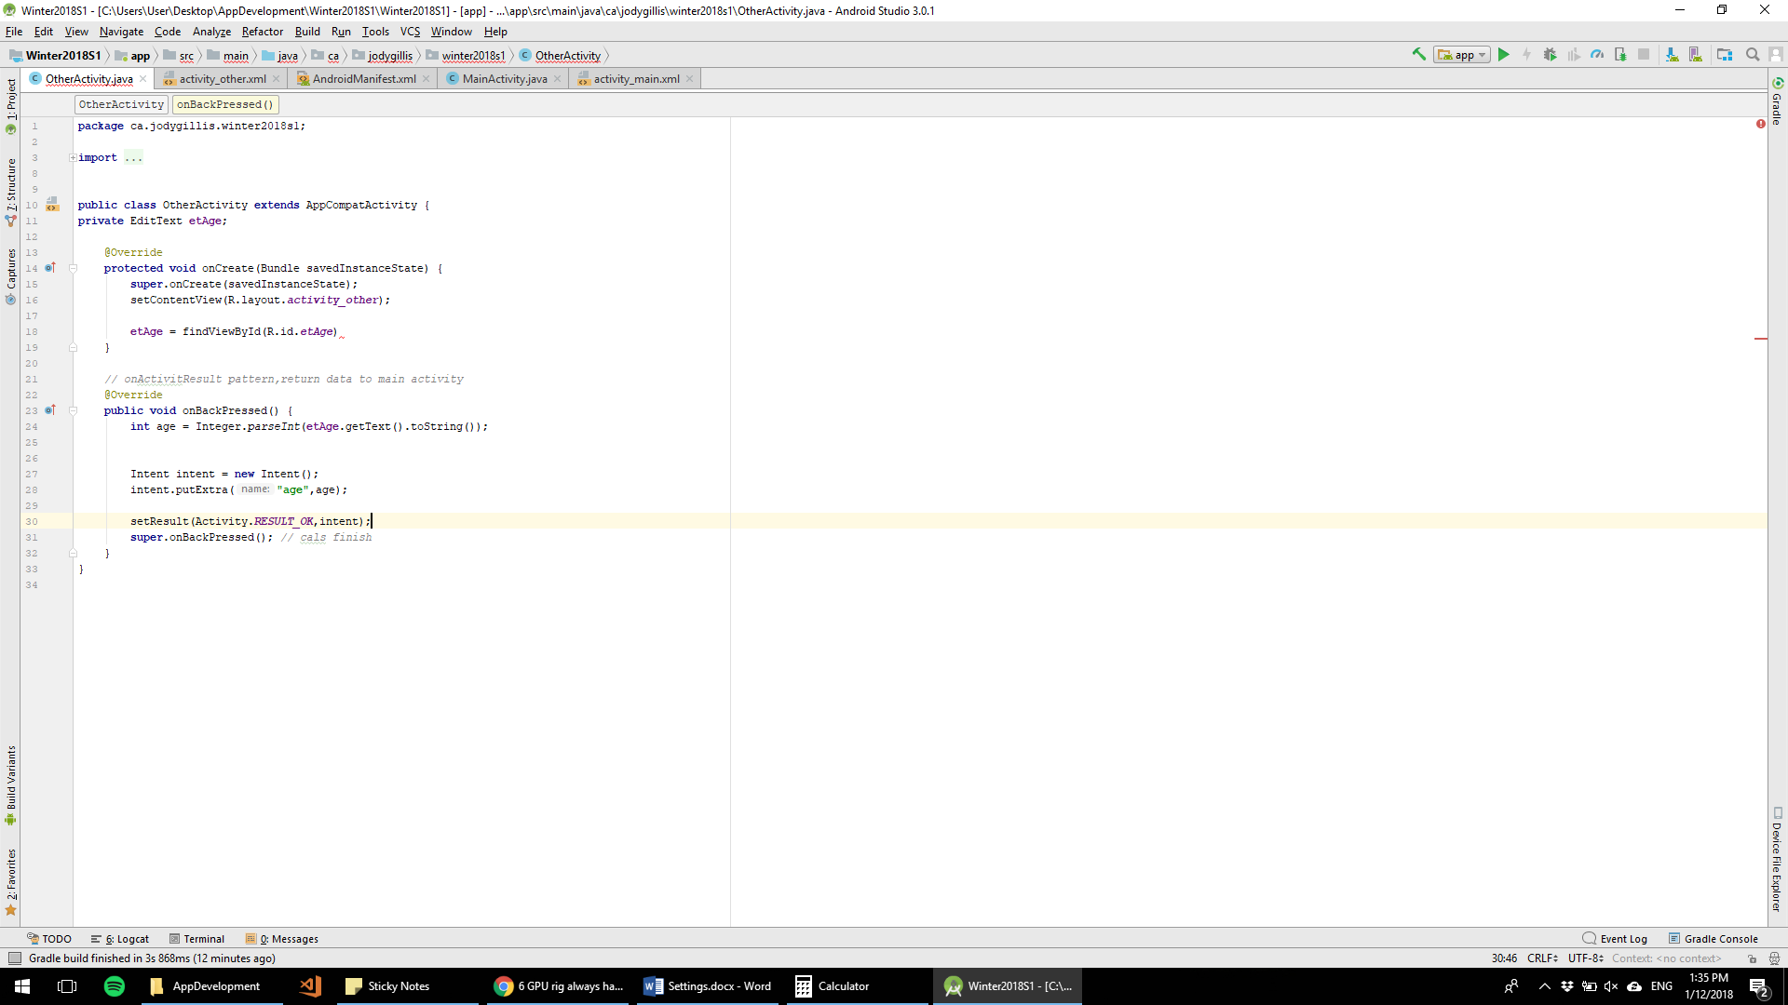

**Main Activity**

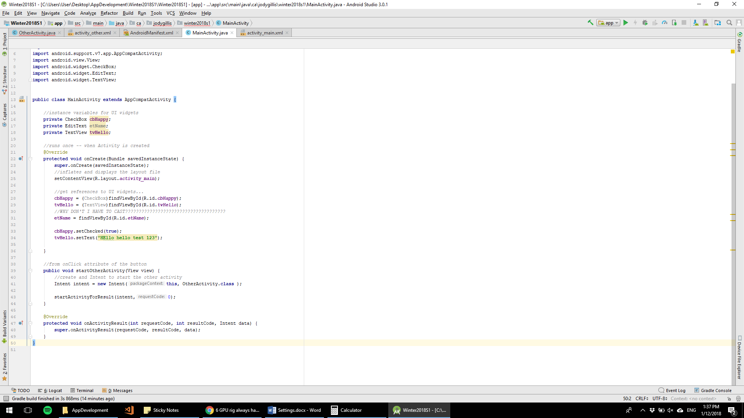

# Lecture 4 – 1/18/2018

## Nested Classes

Implement class within another class. Can be handy to override method for EventHandler in the same activity. Will only affect activity where this class is created

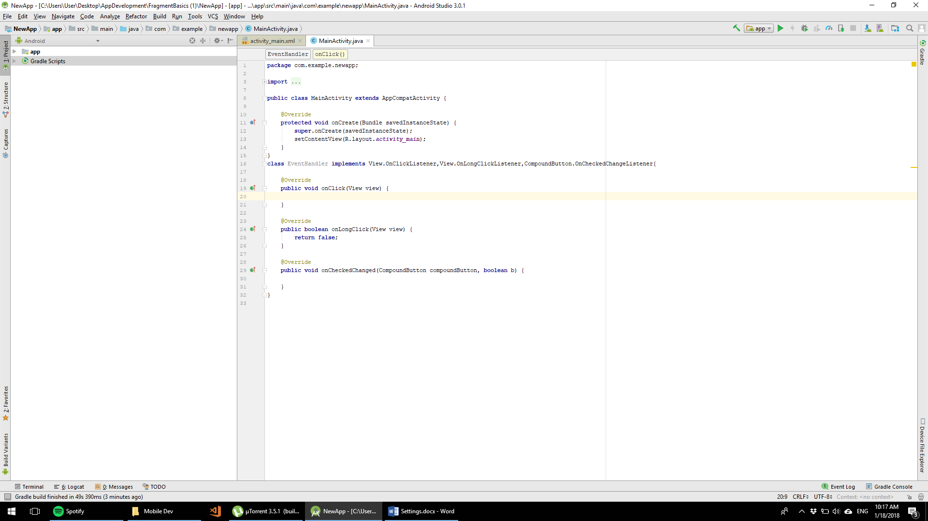

Now we can set all our controls to use Event Handler as their Event Handlers

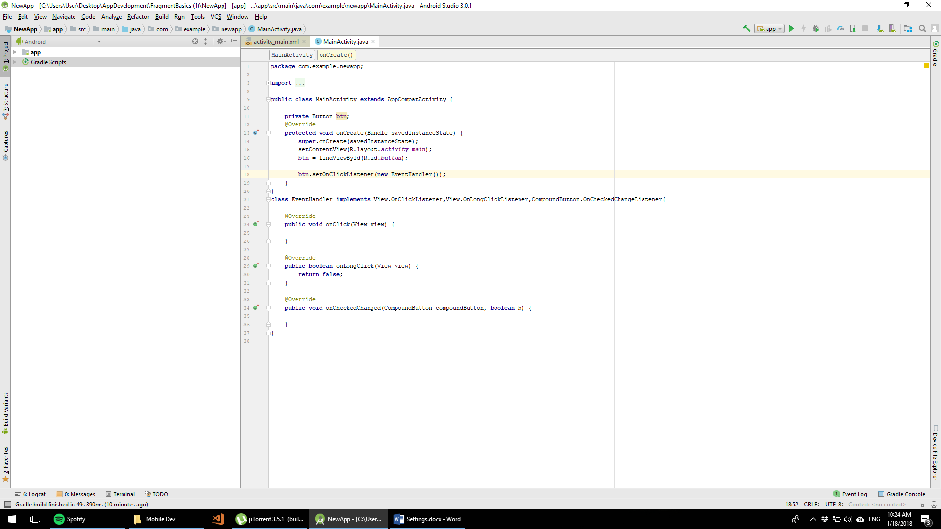

## Shared preferences

Pass data from OnPause method to OnResume

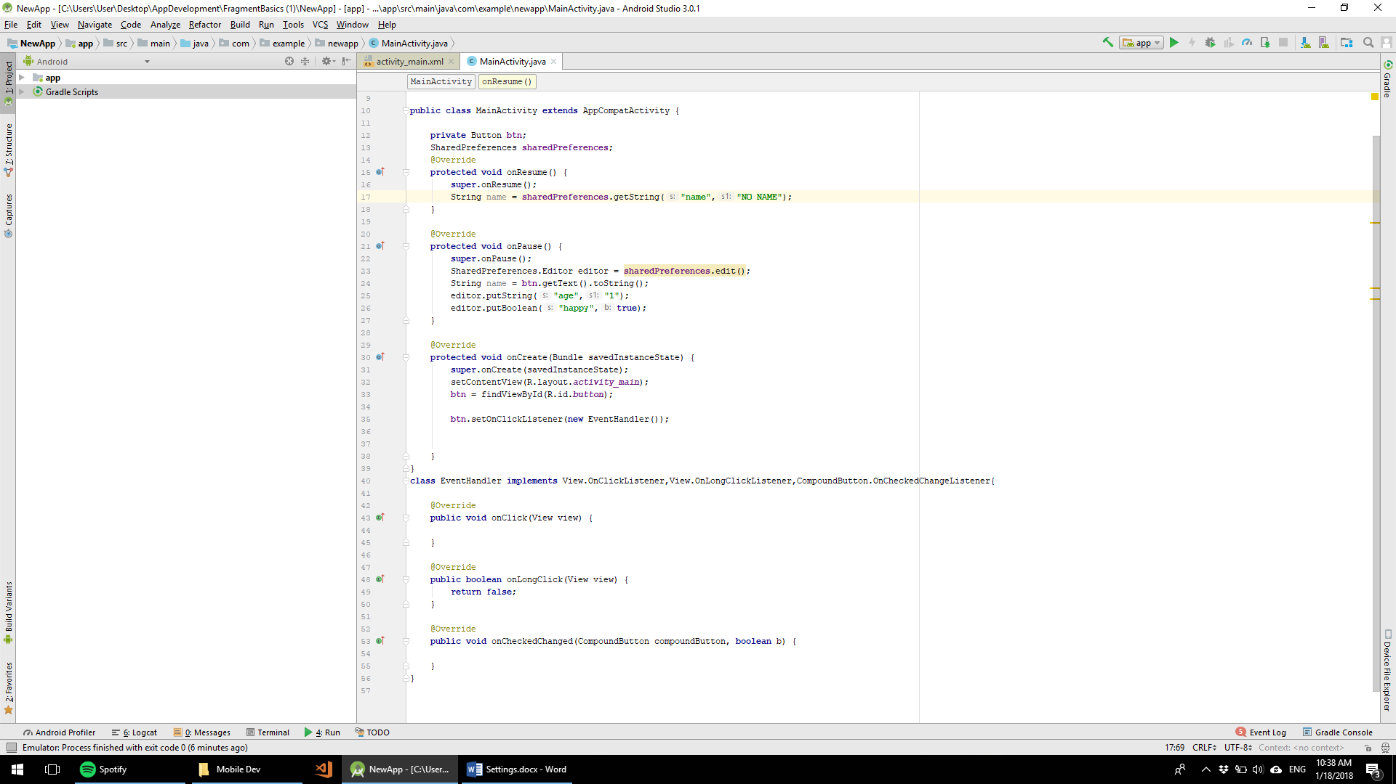

## Emulator Accelerator

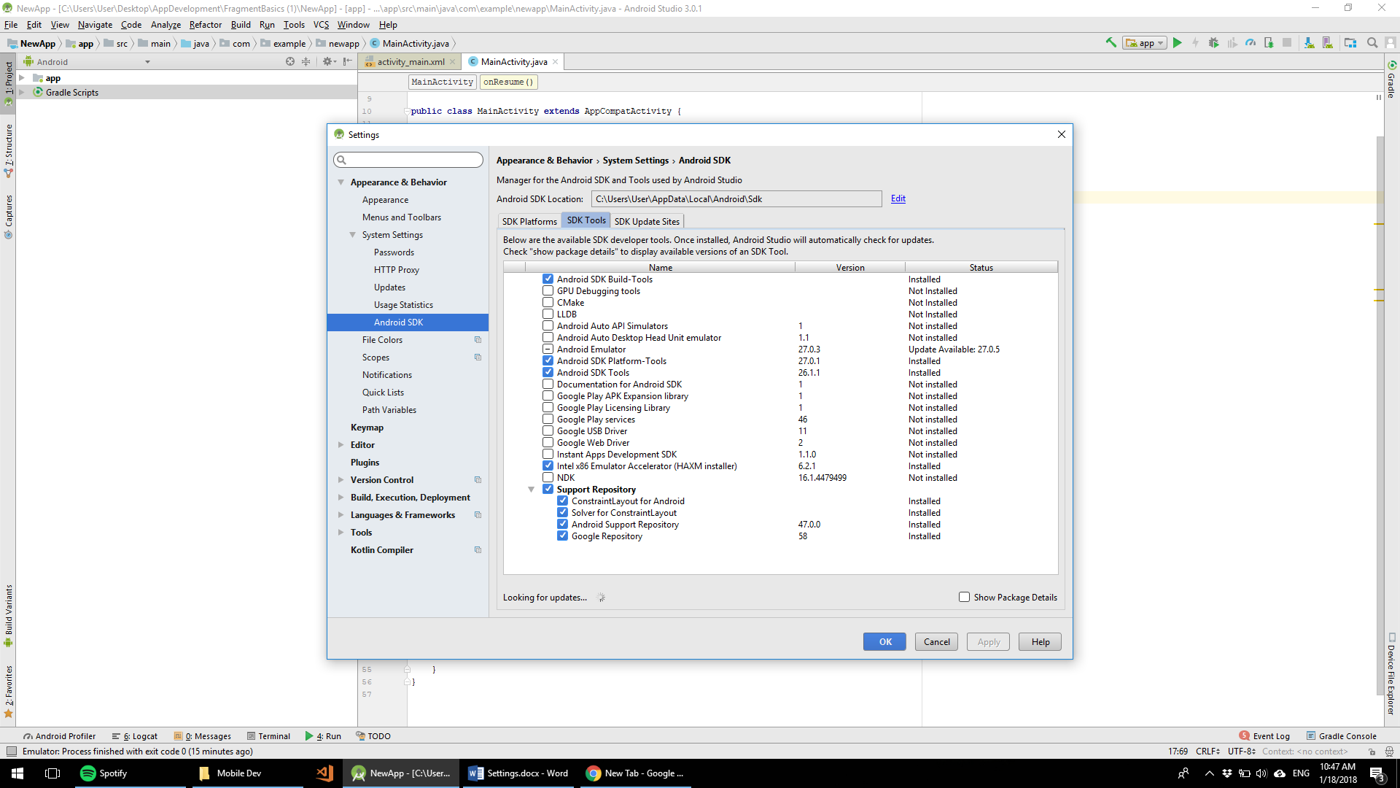

## Assignment 5 – Calculator

Possible to use Example Layout or Create your own

Do error checking

First Activity: Name, Age Input

Input 3 ( Check Input type- has to be numeric)

Input 4 ( Check Input type- has to be numeric)

Result

Buttons for + - x / !

Button that Start Activity 2

Second: Name, Age – Load from shared preferences from activity 1

Date Picker

Button Save, Load

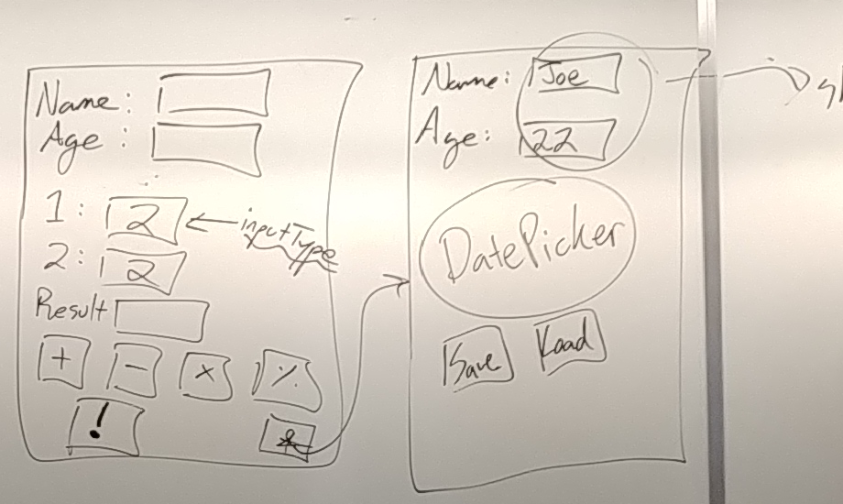

# Lecture 6 – 1/19/2018

## Get google maps api key

Debug key hash + project name + your id = API KEY

Creating api key

Paste this link to the browser

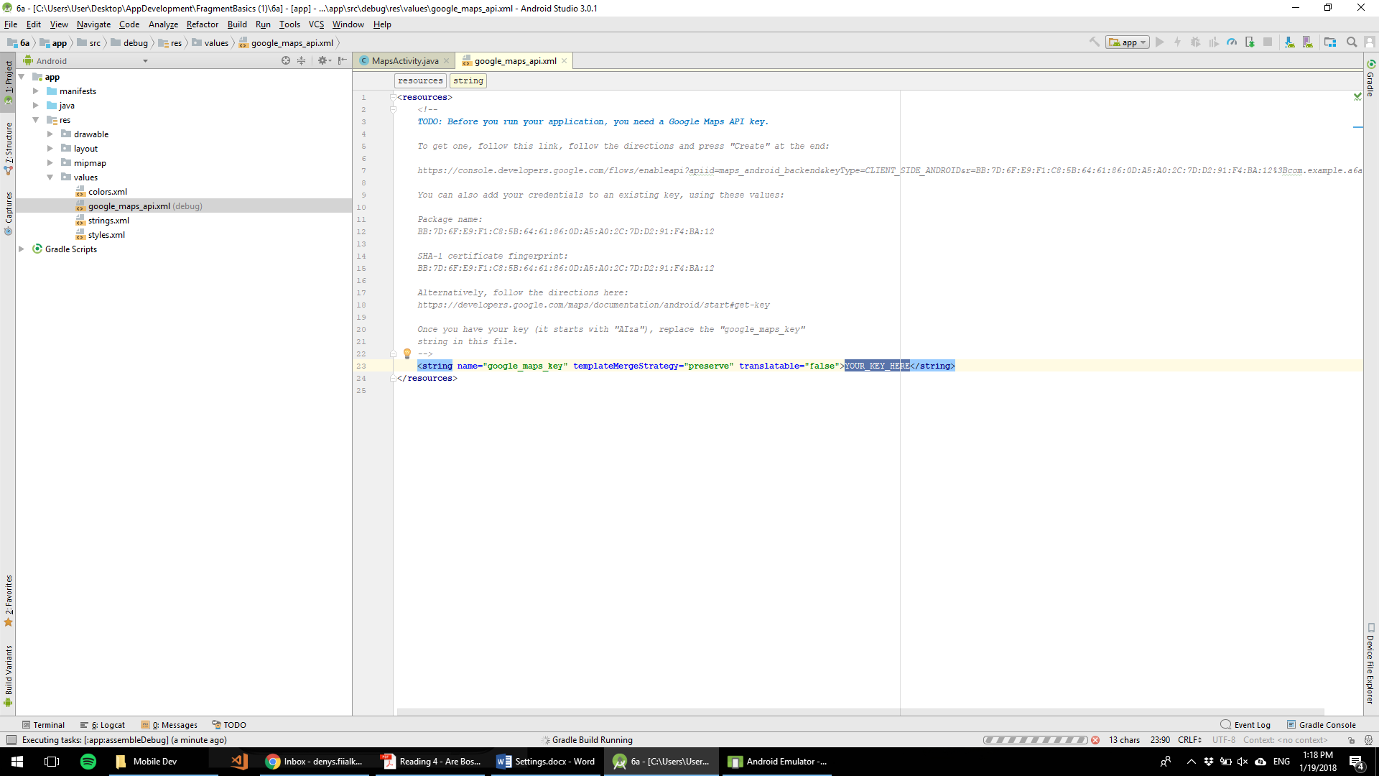

New project -- > Create API key

# Add permission

AndroidManifest.xml = > Type: “user permission” will give a list of available cases

# Lecture 7 – 1/29/2018

## Multithreading

SAXParser – used for multithreading

# Lecture 8 – 2/1/2018

## Initialization block

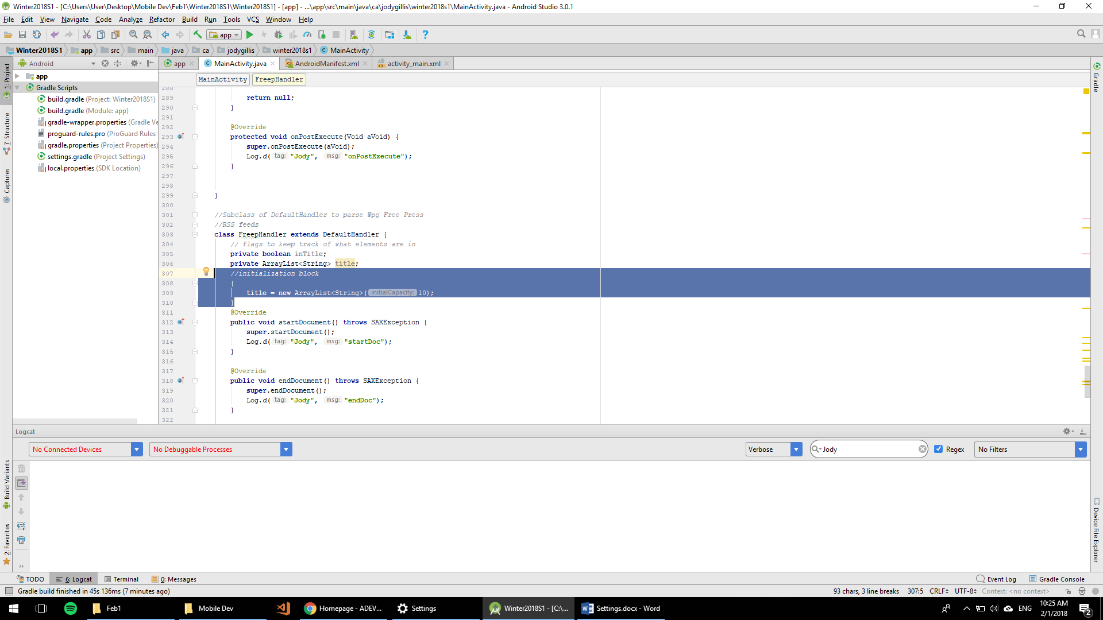

Lecture 9

String Builder